**CHASE BANK LOAN REPORT | SUMMARY**

**KPI’s:**

Total Loan Applications

SELECT COUNT(id) AS Total_Loan_Applications FROM bank_loan_data



MTD Loan Applications

SELECT COUNT(id) AS MTD_Total_Loan_Applications FROM bank_loan_data

WHERE MONTH(issue_date) = 12 AND YEAR(issue_date) = 2021



PMTD Loan Applications

SELECT COUNT(id) AS PMTD_Total_Loan_Applications FROM bank_loan_data

WHERE MONTH(issue_date) = 11 AND YEAR(issue_date) = 2021



Total Funded Amount

SELECT SUM(loan_amount) AS Total_Funded_Amount FROM bank_loan_data



MTD Total Funded Amount

SELECT SUM(loan_amount) AS MTD_Total_Funded_Amount FROM bank_loan_data

WHERE MONTH(issue_date) = 12 AND YEAR(issue_date) = 2021



PMTD Total Funded Amount

SELECT SUM(loan_amount) AS PMTD_Total_Funded_Amount FROM bank_loan_data

WHERE MONTH(issue_date) = 11 AND YEAR(issue_date) = 2021



Total Amount Received

SELECT SUM(total_payment) AS Total_Amount_Received FROM bank_loan_data

MTD Total Amount Received

SELECT SUM(total_payment) AS MTD_Total_Amount_Received FROM bank_loan_data

WHERE MONTH(issue_date) = 12 AND YEAR(issue_date) = 2021



PMTD Total Amount Received

SELECT SUM(total_payment) AS PMTD_Total_Amount_Received FROM bank_loan_data

WHERE MONTH(issue_date) = 11 AND YEAR(issue_date) = 2021



Average Interest Rate

SELECT ROUND(AVG(int_rate), 4) * 100 AS Avg_Interest_Rate FROM bank_loan_data



MTD Average Interest Rate

SELECT ROUND(AVG(int_rate), 4) * 100 AS MTD_Avg_Interest_Rate FROM bank_loan_data

WHERE MONTH(issue_date) = 12 AND YEAR(issue_date) = 2021



PMTD Average Interest Rate

SELECT ROUND(AVG(int_rate), 4) * 100 AS PMTD_Avg_Interest_Rate FROM bank_loan_data

WHERE MONTH(issue_date) = 11 AND YEAR(issue_date) = 2021



Average Debt-to-Income Ratio (DTI)

SELECT ROUND(AVG(dti),4) *100 AS Avg_DTI FROM bank_loan_data



MTD Average Debt-to-Income Ratio (DTI)

SELECT ROUND(AVG(dti),4) *100 AS MTD_Avg_DTI FROM bank_loan_data

WHERE MONTH(issue_date)= 12 AND YEAR(issue_date) = 2021



PMTD Average Debt-to-Income Ratio (DTI)

SELECT ROUND(AVG(dti),4) *100 AS PMTD_Avg_DTI FROM bank_loan_data

WHERE MONTH(issue_date)= 11 AND YEAR(issue_date) = 2021

**Good Loan:**

Good Loan Percentage

SELECT

(COUNT(CASE WHEN loan_status = 'Fully Paid' OR loan_status = 'Current' THEN id END)* 100)

/

COUNT(id) AS Good_loan_percentage

FROM bank_loan_data



Good Loan Applications

SELECT COUNT(id) AS Good_Loan_Applications FROM bank_loan_data

WHERE loan_status = 'Fully Paid' OR loan_status = 'Current'



Good Loan Funded Amount

SELECT SUM(loan_amount) AS Good_Loan_Funded_Amount FROM bank_loan_data

WHERE loan_status = 'Fully Paid' OR loan_status = 'Current'



Good Loan Total Received Amount

SELECT SUM(total_payment) AS Good_Loan_Received_Amount FROM bank_loan_data

WHERE loan_status = 'Fully Paid' OR loan_status = 'Current'



**Bad Loan:**

Bad Loan Percentage

SELECT

(COUNT(CASE WHEN loan_status = 'Charged Off' THEN id END) * 100.0)

/

COUNT(id) AS Bad_loan_percentage

FROM bank_loan_data



Bad Loan Applications

SELECT COUNT(id) AS Bad_Loan_Applications FROM bank_loan_data

WHERE loan_status = 'Charged Off'



Bad Loan Funded Amount

SELECT SUM(loan_amount) AS Bad_Loan_Funded_Amount FROM bank_loan_data

WHERE loan_status = 'Charged Off'



Bad Loan Total Received Amount

SELECT SUM(total_payment) AS Bad_Loan_Received_Amount FROM bank_loan_data

WHERE loan_status = 'Charged Off'



**Loan Status:**

SELECT

loan_status,

COUNT(id) AS Total_Loan_Applications,

SUM(total_payment) AS Total_Amount_Received,

SUM(loan_amount) AS Total_Funded_Amount,

AVG(int_rate * 100) AS Interest_Rate,

AVG(dti*100) AS DTI

FROM

bank_loan_data

GROUP BY

loan_status

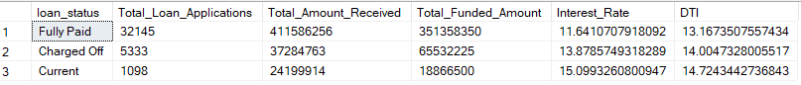

SELECT

loan_status,

SUM(total_payment) AS MTD_Total_Amount_Received,

SUM(loan_amount) AS MTD_Total_Funded_Amount

FROM bank_loan_data

WHERE MONTH(issue_date) = 12

GROUP BY loan_status

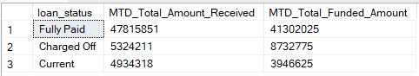

**Monthly Trends by Issue Date:**

SELECT

MONTH(issue_date),

DATENAME(MONTH, issue_date) AS Month_Name,

COUNT(id) AS Total_Loan_Applications,

SUM(loan_amount) AS Total_Funded_Amount,

SUM(total_payment) AS Total_Received_Amount

FROM

bank_loan_data

GROUP BY

MONTH(issue_date), DATENAME(MONTH, issue_date)

ORDER BY

MONTH(issue_date)

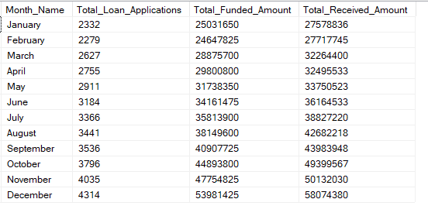

**Regional Analysis by State:**

SELECT

address_state,

COUNT(id) AS Total_Loan_Applications,

SUM(loan_amount) AS Total_Funded_Amount,

SUM(total_payment) AS Total_Received_Amount

FROM

bank_loan_data

GROUP BY

address_state

ORDER BY

COUNT(id) DESC

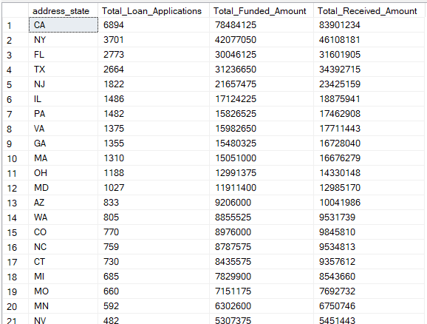

**Loan Term Analysis:**

SELECT

term,

COUNT(id) AS Total_Loan_Applications,

SUM(loan_amount) AS Total_Funded_Amount,

SUM(total_payment) AS Total_Received_Amount

FROM

bank_loan_data

GROUP BY

term

ORDER BY

Term

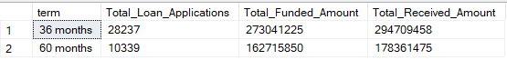

**Employee Length Analysis:**

SELECT

emp_length,

COUNT(id) AS Total_Loan_Applications,

SUM(loan_amount) AS Total_Funded_Amount,

SUM(total_payment) AS Total_Received_Amount

FROM

bank_loan_data

GROUP BY

emp_length

ORDER BY

COUNT(id) DESC

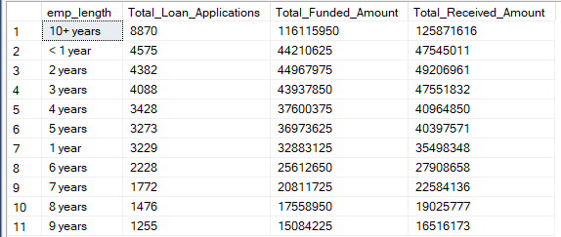

**Loan Purpose Breakdown:**

SELECT

purpose,

COUNT(id) AS Total_Loan_Applications,

SUM(loan_amount) AS Total_Funded_Amount,

SUM(total_payment) AS Total_Received_Amount

FROM

bank_loan_data

GROUP BY

purpose

ORDER BY

COUNT(id) DESC

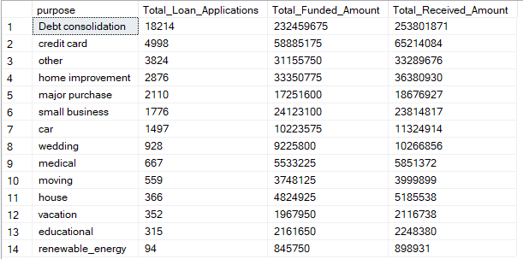

**Home Ownership Analysis:**

SELECT

home_ownership,

COUNT(id) AS Total_Loan_Applications,

SUM(loan_amount) AS Total_Funded_Amount,

SUM(total_payment) AS Total_Received_Amount

FROM

bank_loan_data

GROUP BY

home_ownership

ORDER BY

COUNT(id) DESC

